The Fifty-fourth Massachusetts Infantry
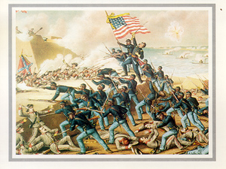
In January 1863, Secretary of War Stanton finally gave John A. Andrew, the abolitionist governor of Massachusetts, authorization to form regiments that could "include persons of African descent. . ." The governor had long been an advocate of raising black regiments from the free black population. Like most abolitionists, he felt the surest path to citizenship for black Americans was for them to be allowed to fight and die for their freedom and their country.
Andrew chose the white officers for the new black regiment from wealthy families prominent in the abolition movement in his state. These families could also be counted on to help finance the enlistment and outfitting of the troops. He solicited the aid of Frederick Douglass and other well known black abolitionists in attracting the cream of the black population for the new regiment. Two of Douglass's sons joined the regiment. Given the considerable opposition in the North to the idea of making soldiers of blacks, the new regiment was seen as a good test of the fitness of black men as soldiers and citizens. Supporters of the regiments spared no expense in the effort to prove that blacks were equal to the test.
The 54th Massachusetts Regiment was the first black regiment recruited in the North. Col. Robert Gould Shaw, the 25 year old son of very wealthy abolitionist parents, was chosen to command. On May 28, the well equipped and drilled 54th paraded through the streets of Boston and then boarded ships bound for the coast of South Carolina. Their first conflict with Confederate soldiers came on July 16, when the regiment repelled an attack on James Island. But on July 18 came the supreme test of the courage and valor of the black soldiers; they were chosen to lead the assault on Battery Wagner, a Confederate fort on Morris Island at Charleston. In addressing his soldiers before leading them in charge across the beach, Colonel Shaw said, "I want you to prove yourselves. The eyes of thousands will look on what you do tonight."

Questions
- What event started the use of African American troops during the Civil War?

- According to the reading, which groups and individuals helped raise the regiment?

- What is an abolitionist?

- Why did the abolitionists feel creating African American regiments was important?

- Who was the leader of the regiment?

- How did the south react after learning the north was using African American troops?

- What types of discrimination did the regiment face from other union army units?

- What battle did the regiment prove its courage at during the Civil War?

- What impact do you think this regiment has on the Civil War?

- What legacy did the regiment leave behind?

