War of the Currents
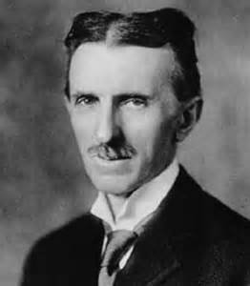
In November and December of 1887, Nikola Tesla filed for seven U.S. patents in the field of electric AC motors and power transmission. These comprised a complete system of generators, transformers, transmission lines, motors and lighting. So original were the ideas that they were issued without a successful challenge, and would turn out to be the most valuable patents since the telephone.
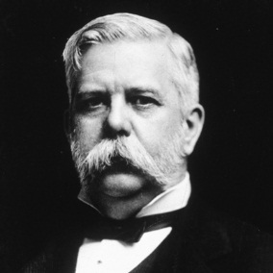
An adventurous Pittsburgh industrialist named George Westinghouse, inventor of railroad air brakes, heard about Tesla's invention and thought it could be the missing link in long-distance power transmission. He came to Tesla's lab and made an offer, purchasing the patents for $60,000, which included $5,000 in cash and 150 shares of stock in the Westinghouse Corporation. He also agreed to pay royalties of $2.50 per horsepower of electrical capacity sold. With more inventions in mind, Tesla quickly spent half of his newfound wealth on a new laboratory.
Tesla
With the breakthrough provided by Tesla's patents, a full-scale industrial war erupted. At stake, in effect, was the future of industrial development in the United States, and whether Westinghouse's alternating current or Edison's direct current would be the chosen technology.
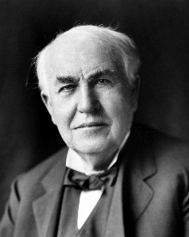
It was at this time that Edison launched a propaganda war against alternating current. Westinghouse recalled:
Westinghouse
I remember Tom Edison telling them that direct current (D.C) was like a river flowing peacefully to the sea, while alternating current (A.C.) was like a torrent rushing violently over a precipice. Imagine that! Why they even had a professor named Harold Brown who went around talking to audiences... and electrocuting dogs and old horses right on stage, to show how dangerous alternating current was.
Edison
Meanwhile, a murderer was about to be executed in the first electric chair at New York's Auburn State Prison. Professor Brown had succeeded in illegally purchasing a used Westinghouse generator in order to demonstrate once and for all the extreme danger of alternating current. The guinea pig was William Kemmler, a convicted ax-murderer, who died horribly on August 6, 1890, in "an awful spectacle, far worse than hanging." The technique was later dubbed "Westinghousing."
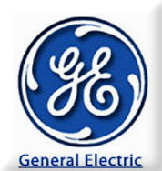
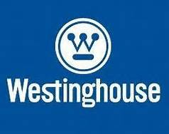
In spite of the bad press, good things were happening for Westinghouse and Tesla. The Westinghouse Corporation won the bid for illuminating The Chicago World's Fair, the first all-electric fair in history. The fair was also called the Columbian Exposition — in celebration of the 400th Anniversary of Columbus discovering America. Up against the newly formed General Electric Company (the company that had taken over the Edison Company), Westinghouse undercut GE's million-dollar bid by half. Much of GE's proposed expenses were tied to the amount copper wire necessary to utilize DC power. Westinghouse's winning bid proposed a more efficient, cost-effective AC system.
The Columbian Exposition opened on May 1, 1893. That evening, President Grover Cleveland pushed a button and a hundred thousand incandescent lamps illuminated the fairground's neoclassical buildings. This "City of Light" was the work of Tesla, Westinghouse and twelve new thousand-horsepower AC generation units located in the Hall of Machinery. In the Great Hall of Electricity, the Tesla polyphase system of alternating current power generation and transmission was proudly displayed. For the twenty-seven million people who attended the fair, it was dramatically clear that the power of the future was AC. From that point forward more than 80 percent of all the electrical devices ordered in the United States were for alternating current.
The Niagara Falls Power Project was an act of pure technological optimism. Americans had dreamed of pressing the Falls into "an honest day's work" since the first pioneer sawmill had been built there in 1725. But schemes for extracting power had never been adequately conceived.
Since his childhood, Tesla himself had dreamed of harnessing the power of the great natural wonder. And in late 1893, his dream became a reality, when Westinghouse was awarded the contract to create the powerhouse.
The contract came as a result of a failed competition spearheaded by the international Niagara Falls Commission. The commission, charged with planning the power project, had solicited proposals from experts around the world only to reject them all. The schemes ranged from a system using pneumatic pressure to one requiring ropes, springs and pulleys. And there were proposals to transmit DC electricity, one endorsed by Edison. At the head of the commission was Lord Kelvin, the famous British physicist, who had been as opposed to alternating current as Edison until he attended the Chicago Exposition. Now, a strong convert to AC, Kelvin and his commission asked Westinghouse to use alternating current to harness the power of the falls.
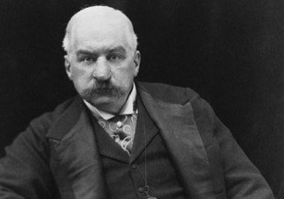
The construction period was traumatic for engineers, mechanics and workers, but it weighed most heavily on investors. Project backers included several of the wealthiest men in America and Europe, including: J. P. Morgan, John Jacob Astor, Lord Rothschild, and W. K. Vanderbilt. After a five-year nightmare of doubt and financial crises, the project approached completion. Tesla had not doubted the results for a moment. The investors, however, were not at all sure the system would work. While the machines were running smoothly in Tesla's three-dimensional imagination, they were still unproved and expensive.
But the worries were unwarranted. When the switch was thrown, the first power reached Buffalo at midnight, November 16, 1896. The Niagara Falls Gazette reported that day, "The turning of a switch in the big powerhouse at Niagara completed a circuit which caused the Niagara River to flow uphill." The first one thousand horsepower of electricity surging to Buffalo was claimed by the street railway company, but already the local power company had orders from residents for five thousand more. Within a few years the number of generators at Niagara Falls reached the planned ten, and power lines were electrifying New York City. Broadway was ablaze with lights; the elevated, street railways, and subway system rumbled; and even the Edison systems converted to alternating current.
J.P. Morgan
- What types of patents did Nokola Tesla file for in 1887?

- Who was the Pittsburgh Industrialist who teamed up with Tesla?

- How much did he offer Tesla to work with him?

- Which type of electrical current did Westinghouse and Tesla support?

- Why kinds of propaganda did Thomas Edison use to discredit Tesla and Westinghouse?

- What was the name of the Electric Company formed by Thomas Edison and J.P. Morgan?

- What happened at the Columbian Exposition that opened on May 1, 1893?

- Which company won the bid to supply electricity to the Columbian Exposition?

- What was the first city in the U.S. to be supplied electric power on November 16, 1896?

- Which side ended up more successful in the War of the Currents?

