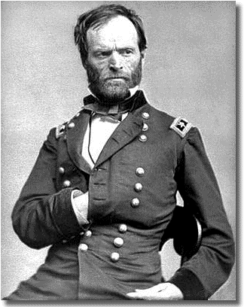
William T. Sherman
to
Henry W. Halleck,

[Excerpt]
Headquarters Military Division of the Mississippi,
In the Field, Savannah, December 24, 1864
Major-General H. W. Halleck,
Chief-of-Staff,
Washington, D.C.
General:
I had the pleasure of receiving your two letters of the 16th and 18th instant to-day, and feel more than usually flattered by the encomiums you have passed on our recent campaign, which is now complete by the occupation of Savannah....
I attach more importance to these deep incisions into the enemy's country, because this war differs from European wars in this particular: we are not only fighting hostile armies, but a hostile people, and must make old and young, rich and poor, feel the hard hand of war, as well as their organized armies. I know that this recent movement of mine through Georgia has had a wonderful effect in this respect. Thousands who had been deceived by their lying newspapers to believe that we were being whipped all the time now realize the truth, and have no appetite for a repetition of the same experience. To be sure, Jeff. Davis has his people under pretty good discipline, but I think faith in him is much shaken in Georgia, and before we have done with her South Carolina will not be quite so tempestuous.
I will bear in mind your hint as to Charleston, and do not think "salt" will be necessary. When I move, the Fifteenth Corps will be on the right of the right wing, and their position will naturally bring them into Charleston first; and, if you have watched the history of that corps, you will have remarked that they generally do their work pretty well. The truth is, the whole army is burning with an insatiable desire to wreak vengeance upon South Carolina. I almost tremble at her fate, but feel that she deserves all that seems in store for her.
Many and many a person in Georgia asked me why we did not go to South Carolina; and, when I answered that we were en route for that State, the invariable reply was, "Well, if you will make those people feel the utmost severities of war, we will pardon you for your desolation of Georgia."
I look upon Columbia as quite as bad as Charleston, and I doubt if we will spare the public buildings there as we did at Milledgeville [Georgia]....

SOURCE: Reprinted in William Tecumseh Sherman, Memoirs of General William T. Sherman, vol. 2 (New York, 1875), pages 703-706.

HOMEWORK QUESTIONS

Name:________________________________ Date:______________________

Sherman’s March to the Sea primary document questions

- How does Sherman say the Civil War is different than European Wars?

- What Southern States does Sherman target with his march?

- What does Sherman’s Army have a desire to do?

- What were Sherman’s goals and reasons for the march?

- What does Sherman plan on doing to Columbia South Carolina?

- What does Sherman say the southern newspapers are telling their people about the war?

- How does Sherman say the southern people feel about their president Jefferson Davis?

- Did Sherman’s march help solidify a Union victory? Why or why not?

9. Was Sherman’s march justified?

